Point cloud segmentation study

The purpose of this study is to investigate how different elements in a user interface affects the performance of a point cloud segmentation task.

A point cloud is a three dimensional point representation of the world (see figure 1). Point clouds are created by combining multiple 3D images from a laser scanner. When you only use one 3D image, you'll find empty areas behind the area where the laser encountered a person or object. Look at the empty areas behind the people and telephone poles to get an idea of what this looks like.

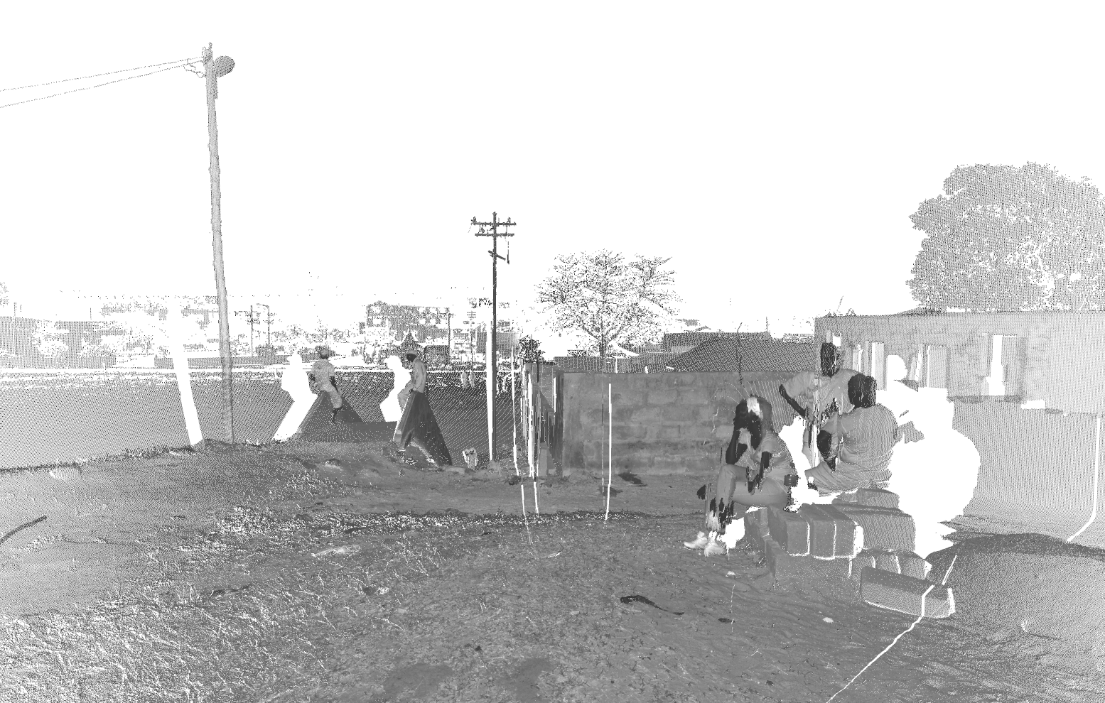Figure 1: Example of a point cloud
When a point cloud only contains the points of a single scan, it can also be viewed as 360 degree panoramic 2D image (see figure 2).

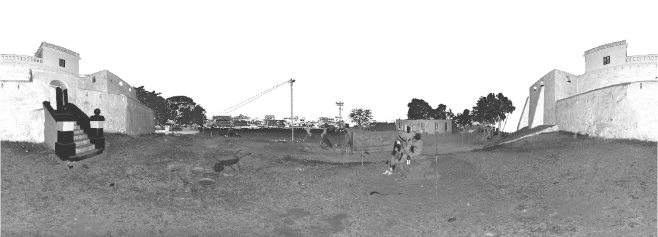Figure 2: A two dimensional 360 panoramic view of a point cloud

In this study we work only with point clouds that contain a single scan, so you'll be able to view it in 2D and 3D.

The viewer we'll be using is called CloudClean (figure 3).

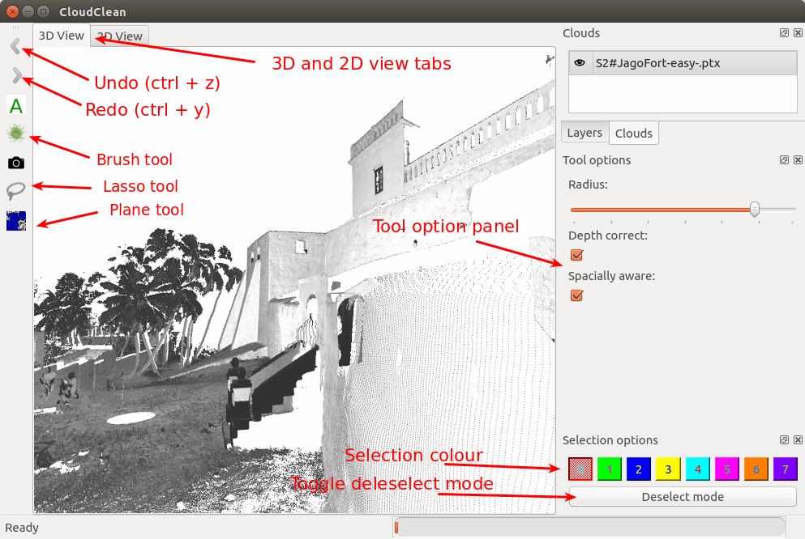Figure 3: CloudClean interface
In 3D mode, CloudClean lets you navigate a scan as if you were in a first person shooter (FPS) (game). You can move forwards (W or up arrow), backwards (S or down arrow), left (A or left arrow), right (D or right arrow) as well as up (E) or down (Q) and look around by holding the left mouse button while moving the mouse. In 2D mode you can pan the image by holding the left mouse button and moving the mouse, as well as zoom in by scrolling (like in google maps).

The main purpose of CloudClean is to let you select collections of points (segmentation). In this study selections can be created via 3 tools namely the brush, lasso, and plane tool (see figure 3). The brush tool lets you select points by clicking and dragging the mouse (see figure 4), the plane tool lets you select flat areas by clicking once (see figure 5), and the lasso tool lets you draw a shape around the points you wish to select (see figure 6&7).
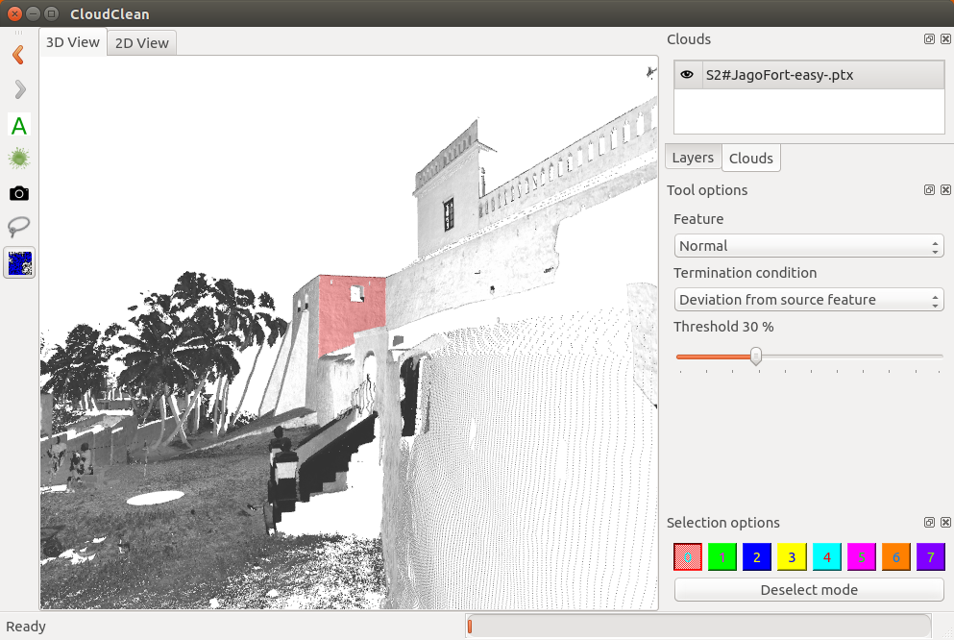Figure 5. Selection with the plane tool
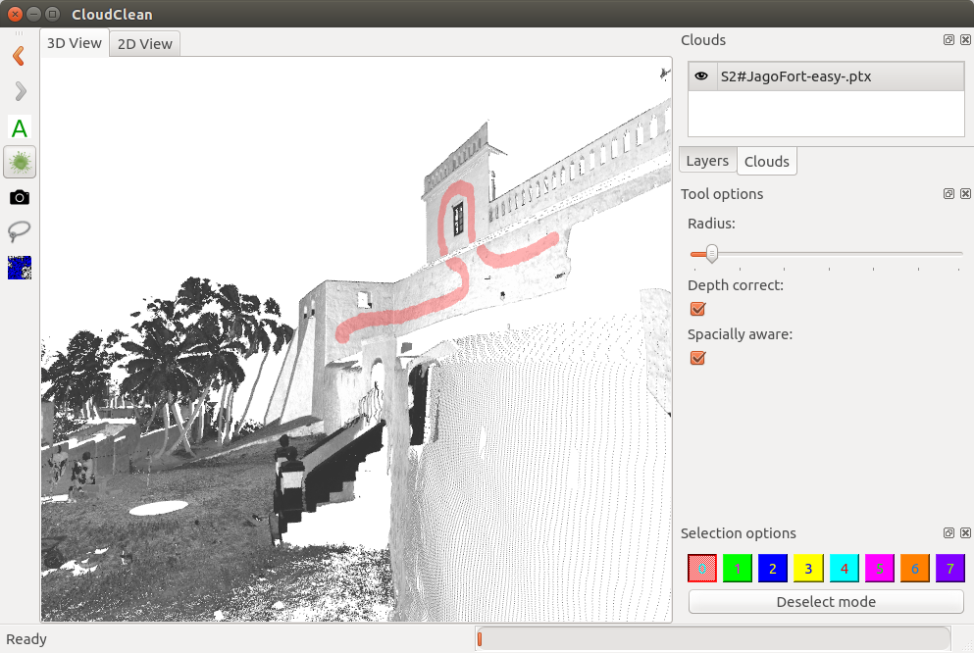Figure 4. Selection with the brush tool

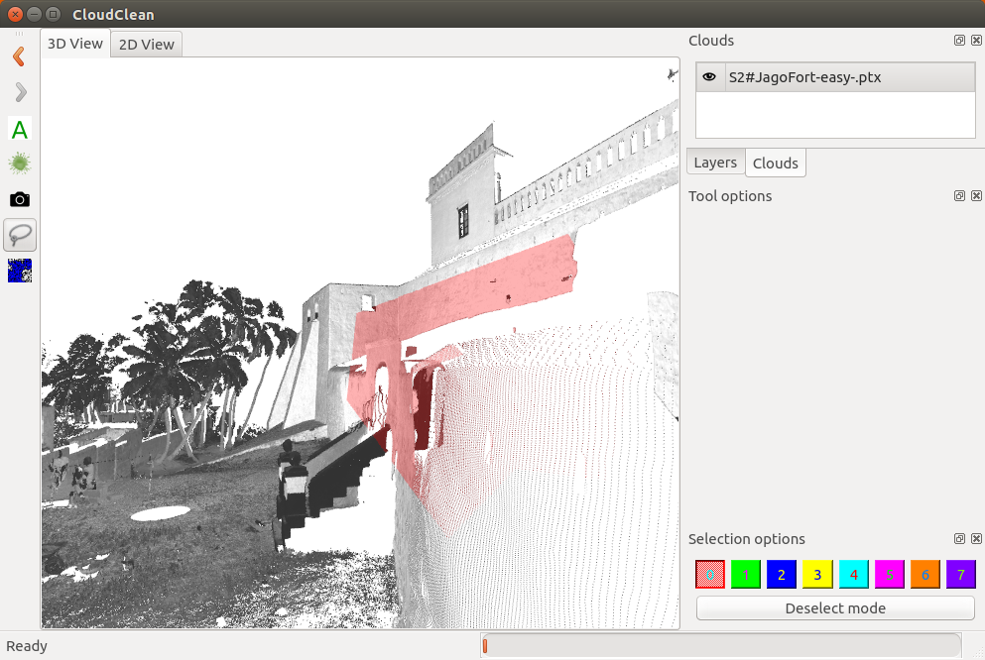Figure 7. Selection with the lasso tool
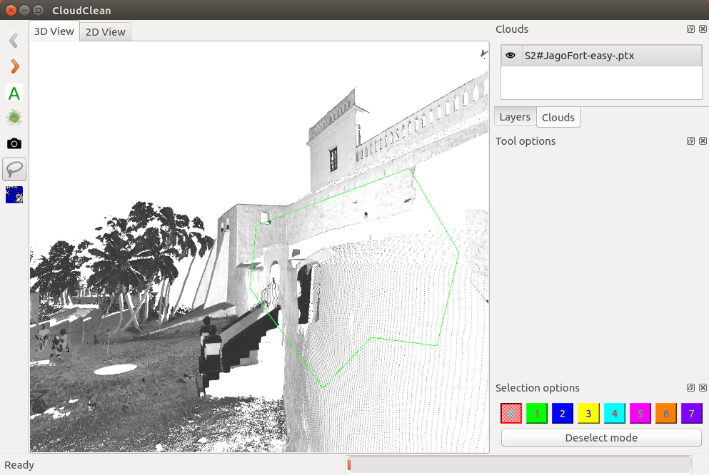Figure 6. Drawing selection area with the lasso tool

During this study you will be asked to perform a series of timed tasks. In the first set of tasks you will be asked to navigate between two locations in the point cloud. Following this you will be presented with a series of segmentation tasks. These will require you to reproduce an existing segmentation with a pre-set level of accuracy. You will be allowed use any of the tools provided, you can also toggle between 2D and 3D views and undo selections via ctrl-z. If you wish to navigate while a tool is active you can hold the shift key.

